- Created and installed docker,kubernetesctl to run commansminikube in local powershell in powershell
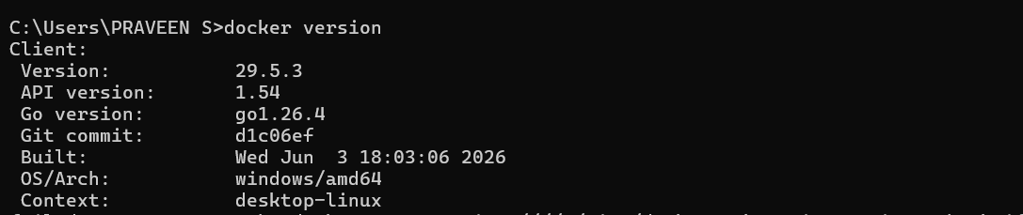

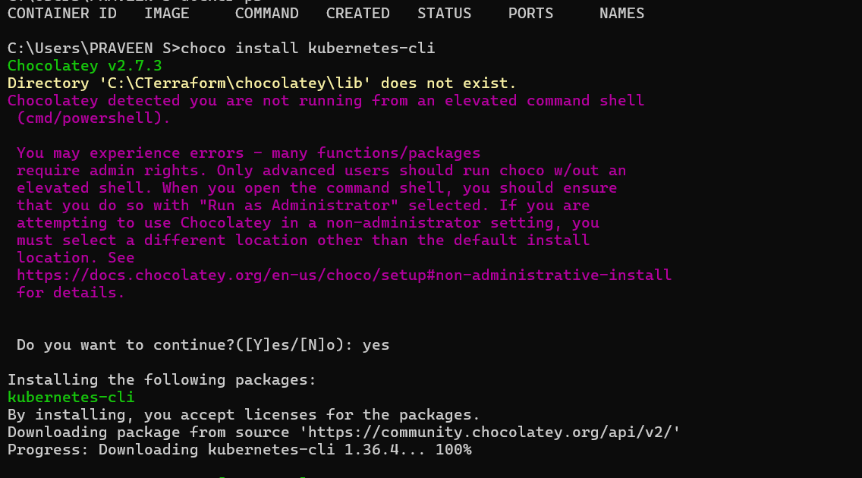
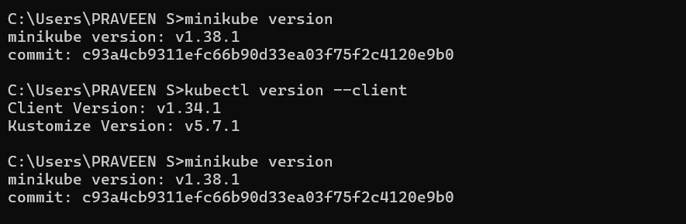
2.created 3 types on namespaces production,development and testing
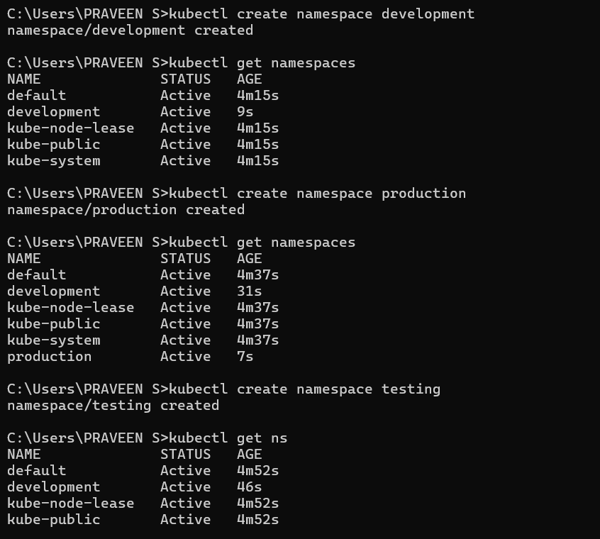
- Also created a testing namespaces using yaml file
